LONTIUM SEMICONDUCTOR CORPORATION

LT1501 Series

LT8912B Linux Driver Software
Debugging Guide

目 录
一 Introduction 3
二 Driver File Introduction 4
三 Add To The Kernel Method 7
四 LT8912B Software Configuration 9
五 Other Debugging Methods 11

一 Introduction

- The LT8912B does not have a built-in MCU, and requires an external MCU or master SOC to read and write registers to the chip through the I2C to work normally.

- The chip register address is 16 bits (the actual read and write operation is based on 8-bit address, the read and write timing can refer to 8-bit address), in which the high 8 bits are the Bank address, and the low 8 bits are the offset address in the Bank.

- Example,the I2C address is 8 bits 0x90 on the MCU. When used on the SOC, it needs to move one bit to the right，and take the higher 7 bits to 0x48.
- The LT8912B chip has three I2C addresses and needs to switch three I2C addresses during initialization.(0x48,0x49,0x4a)

二 Driver File Introduction

① Driver file layout：
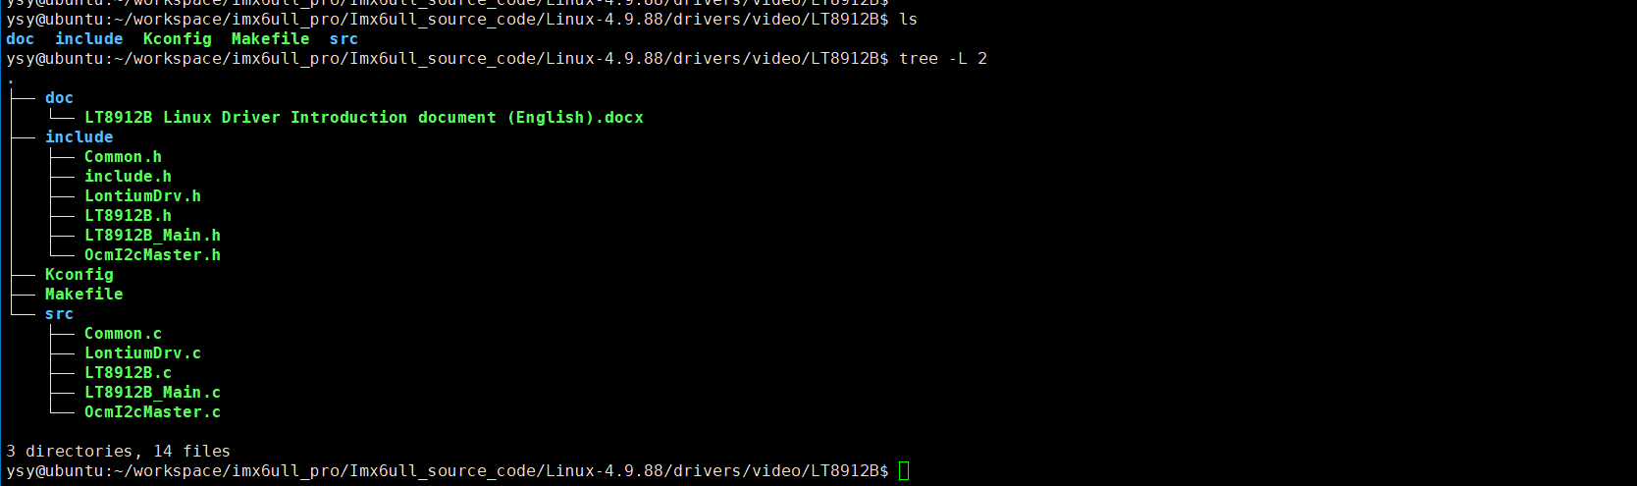
The main documents are described as follows:
- doc: Directory for storing the introduction document
- include: Store all header files of the driver.
- src: Store all *.c files of the driver.
- Kconfig : The configuration file is used to build the driver.
- Makefile: The configuration file is used to build the driver.
- LontiumDrv.c: Linux driver entry file. view the driver logic from this file
- LT8912B_Main.c: The chip configuration entry file is where the chip configuration logic begins.
- Other files: Provides functions that are called during register configuration.
② LontiumDrv.c source code introduction：
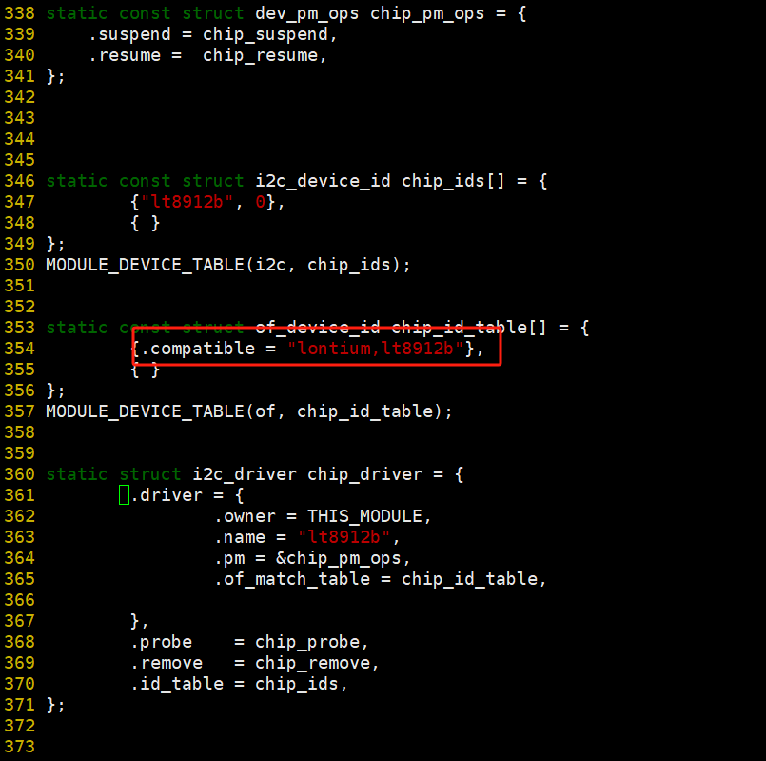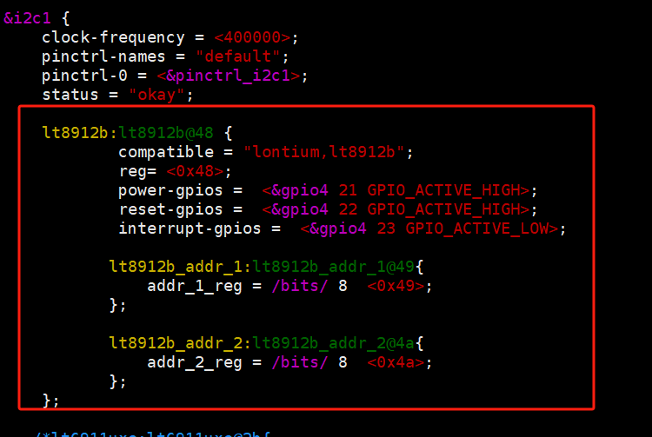

- "lontium,lt8912b": Key characters that match the device tree.
- chip_probe ： Once the driver matches the device tree when insmod, chip_probe is executed.
- chip_pm_ops： Register the sleep function -chip_suspend and wake function -chip_resume, if the platform's power cannot use driver control, also can use control the reset pin.
- device tree: Have three I2C address - 0x48、0x49 and 0x4a.
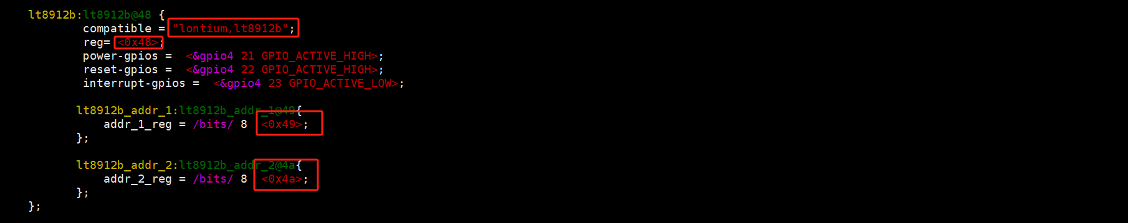

③ chip_probe source code introduction：
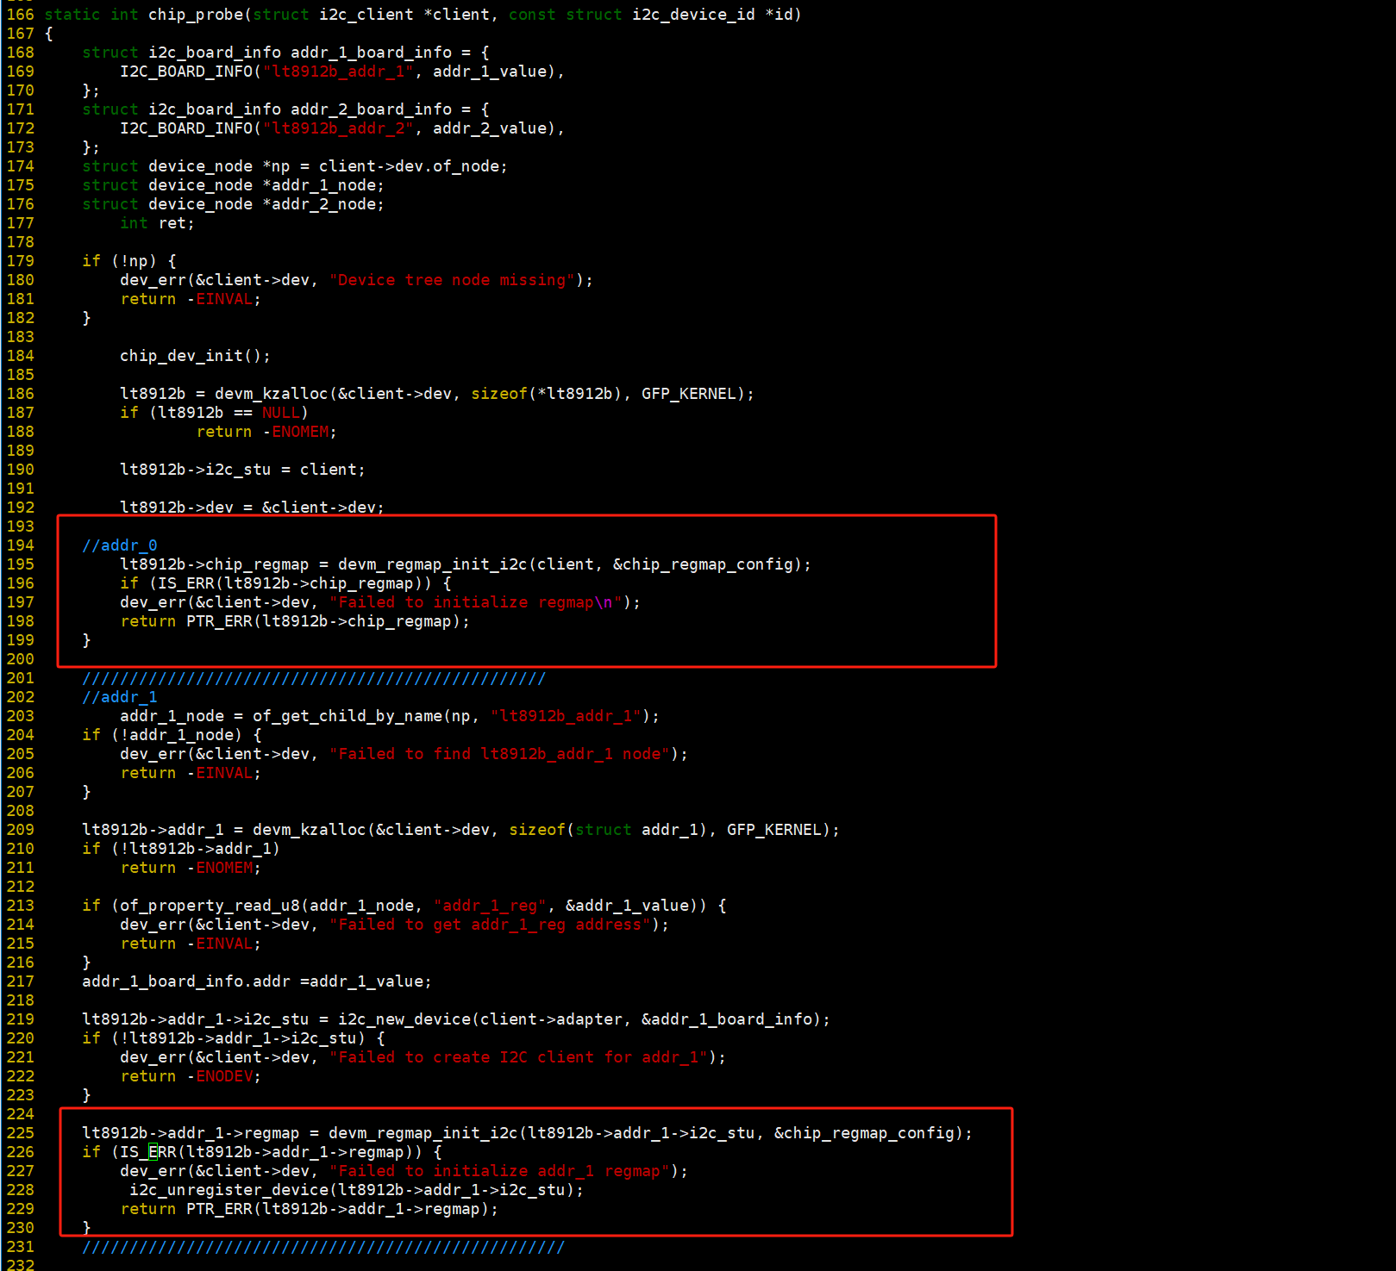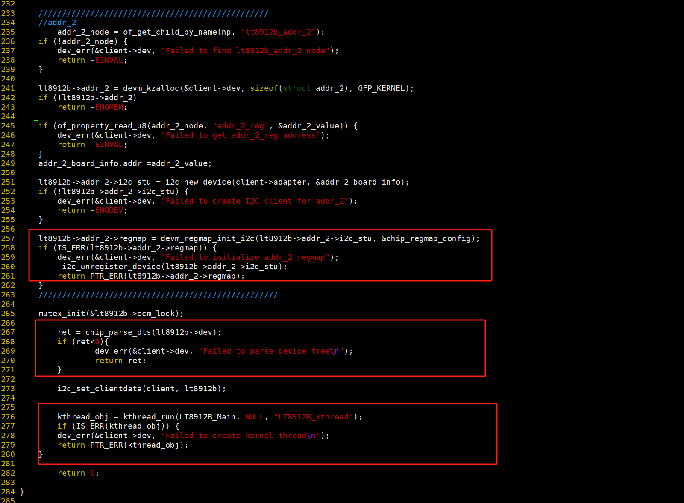
- ret = chip_parse_dts(lt8912b->dev): Parses the GPIO resources configured in the device tree.
- kthread_obj = kthread_run(LT8912B_Main, NULL, "LT8912B_kthread"): Create a thread, call LT8912B_Main function, LT8912B_Main function will initialize the chip.

三 Add To The Kernel Method

- Take adding the source code to the drivers/video directory of the kernel as an example. Create the LT8912B folder in the video directory:
Copy the provided driver source file into the LT8912B directory and configure the driver/video/Makefile and driver/video/Kconfig files that already exist in the video directory:
  - driver/video/Makefile:
  - driver/video/Kconfig:
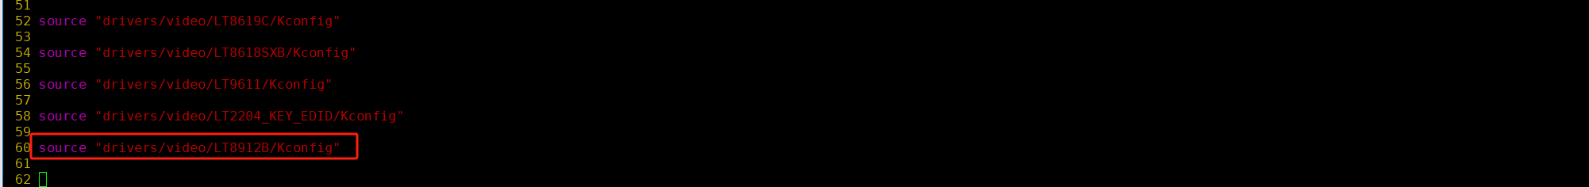

- Go to the LT8912B directory and add the driver/video/LT8912B/Makefile and driver/video/LT8912B/
Kconfig, the source code for these two files is provided, and the configuration content is as follows:
  - driver/video/LT8912B/Makefile:

  - driver/video/LT8912B/Kconfig:

③ Execute the make menuconfig command in the kernel directory, and then configure the added driver to participate in build at build time.At the red line below:
- Select M to compile into a separate ko, which requires manual insmod.
- Select y to be automatically loaded when the kernel starts.
- Select n not to participate in compilation.
- Click Save and Exit to add the configuration to the configuration file .config, and then build.
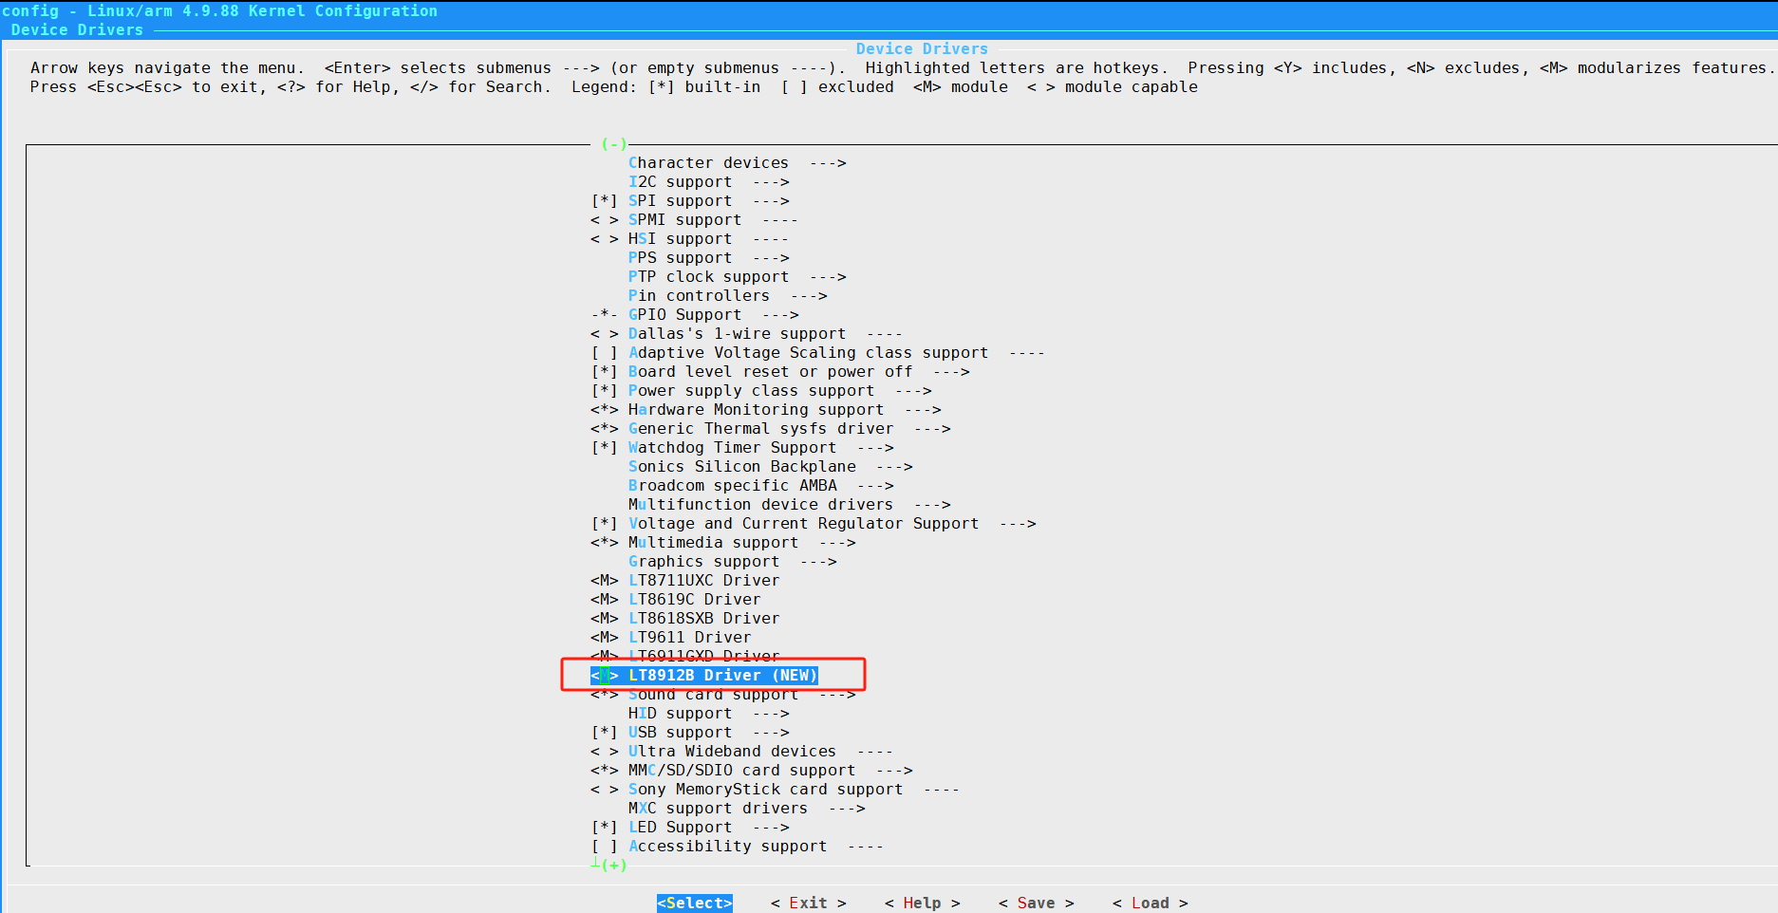
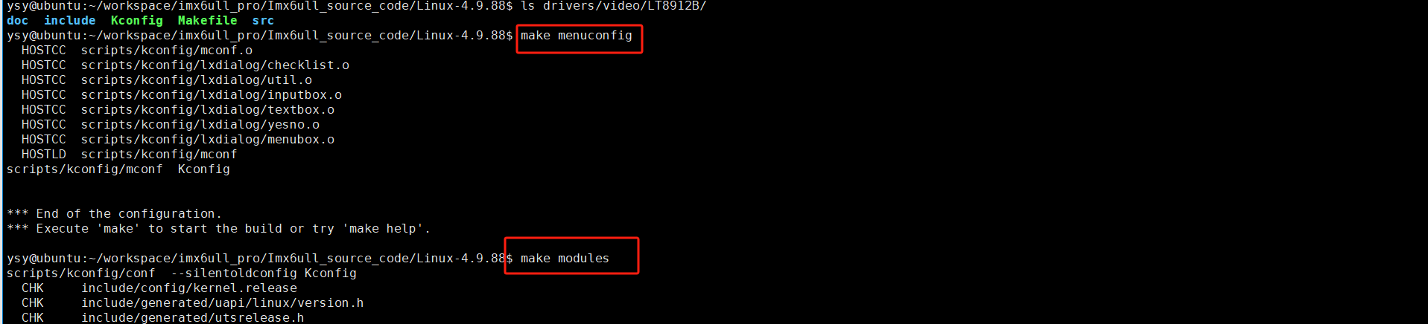

[NOTE]： Also Can set CONFIG_LT8912B to a fixed value in xxxx_defconfig for your platform, so that you don't need make menuconfig.

四 LT8912B Software Configuration

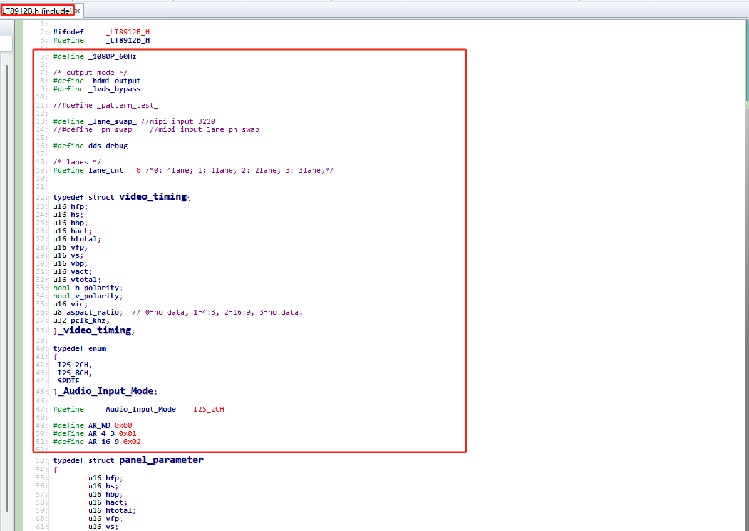

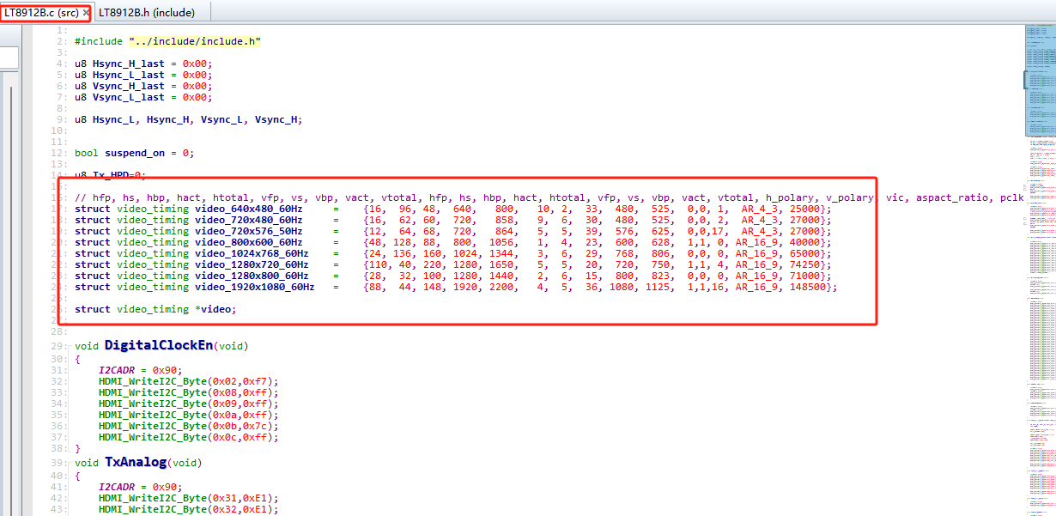
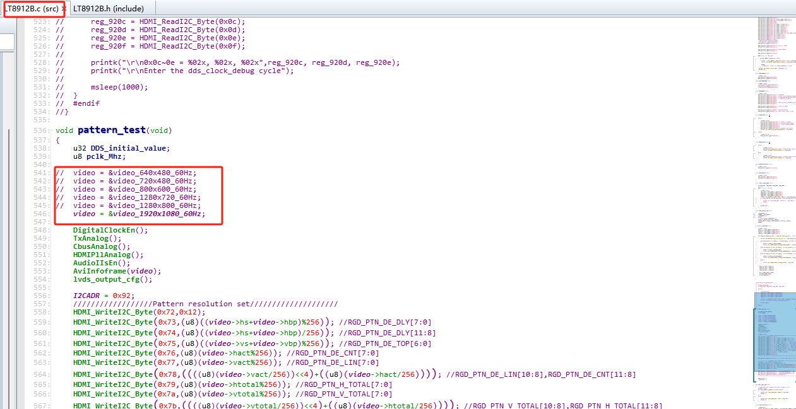

五 Other Debugging Methods

In the early debugging phase, instead of porting code to the kernel directory, driver can be build separately using the following Makefile:
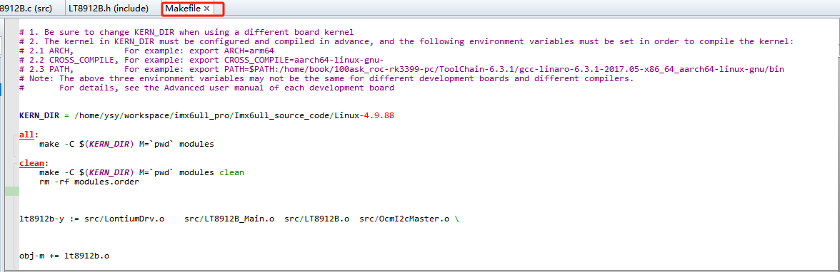
Run the make all command to build the lt8912b.ko driver.
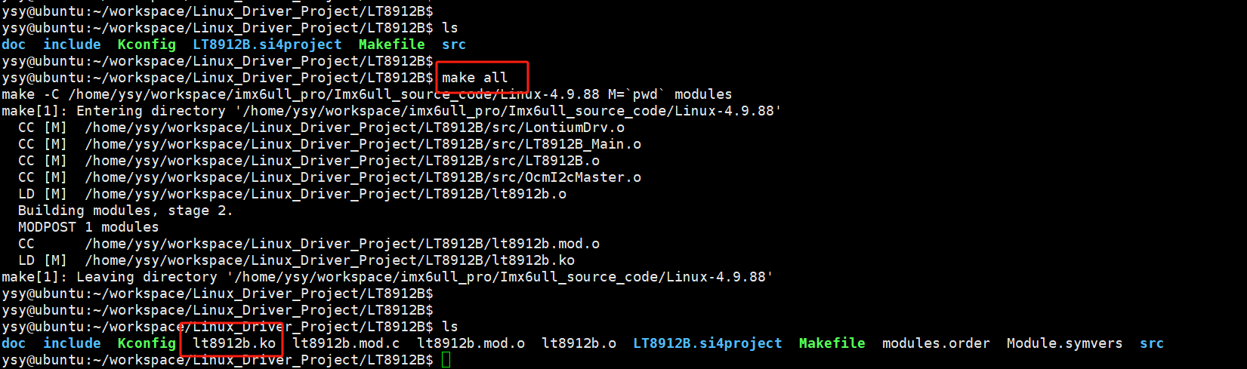

insmod lt8912b.ko for init chip.
